Curvature-Informed Preconditioning
Right now, Adam uses a diagonal approximation of curvature through the second moment v. Each parameter gets its own step size based on its historical gradient magnitude, but Adam completely ignores how parameters relate to each other. It treats every direction independently.
Curvature-informed preconditioning says: before you give the gradient to Adam, transform it using actual curvature information from the problem. Instead of the update being:
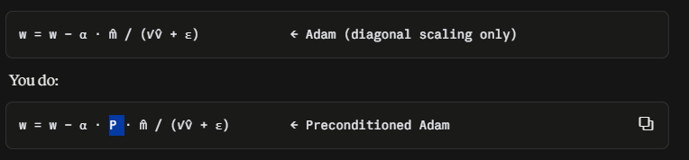
Where P is a preconditioner matrix built from curvature information. P reshapes the gradient so that the loss landscape looks equally curved in all directions. This means Adam no longer has to figure out the relative scaling itself — the preconditioner has already done the hard work.

Current Approaches (Options):
The Hessian H = ∇²f: The matrix of second derivatives. Gives exact curvature but is expensive to compute and store (N² entries for N variables). At N = 100 this is 10,000 entries — manageable in MATLAB. The preconditioned update would be w = w − α · H⁻¹ · g, which is essentially Newton's method.
Diagonal of the Hessian: Just the diagonal entries of H. Same size as Adam's v, but captures true curvature instead of gradient magnitude. Cheap to compute and store.
Fisher Information Matrix: For statistical/ML problems, approximates curvature using gradient outer products. Adam's v is actually a diagonal approximation of this.
Block-diagonal / Kronecker approximations (Shampoo, K-FAC): Capture some cross-parameter correlations without the full N² cost. These are the state of the art for large-scale preconditioning.

Double Gradient Descent (Hypergradient Descent)
"Double gradient descent" refers to optimizing the optimizer's own hyperparameters using gradients. Specifically: you compute the gradient of the loss not just with respect to the design variables (as normal), but also with respect to the learning rate α itself. This "gradient of a gradient" is called a hypergradient.
Using the paper [Baydin et al., "Online Learning Rate Adaptation with Hypergradient Descent" (2018), ICLR]
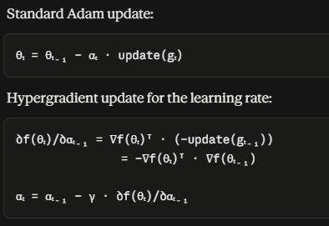
In words: if the current gradient points in the same direction as the previous gradient (their dot product is positive), you should have taken a bigger step — so increase α. If they point in opposite directions (dot product negative), you overshot — so decrease α.
This needs only one extra dot product and one extra stored gradient per iteration. Minimal cost, but eliminates the need to manually tune α.
Testing on the 100D Rosenbrock function (medium sized problem)
Before applying the DG:

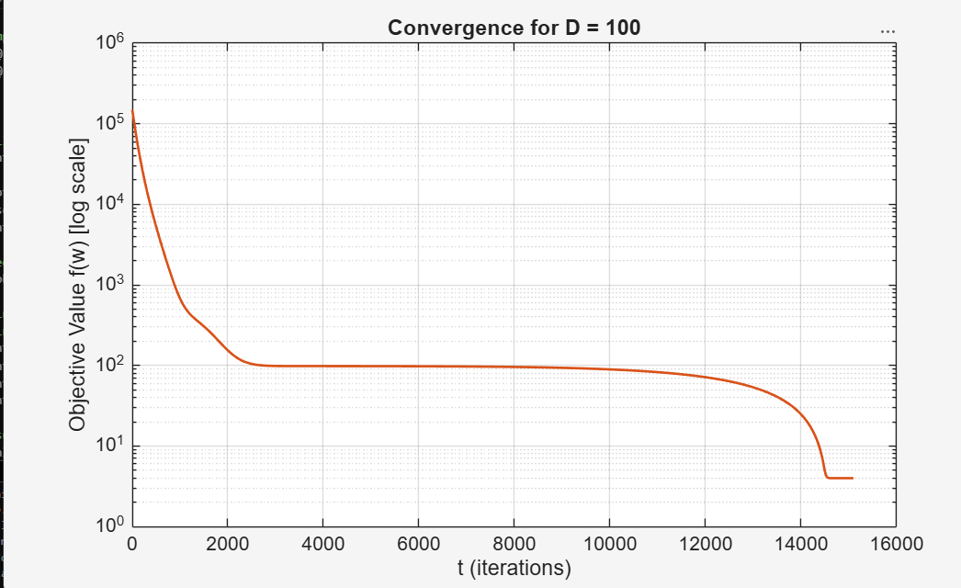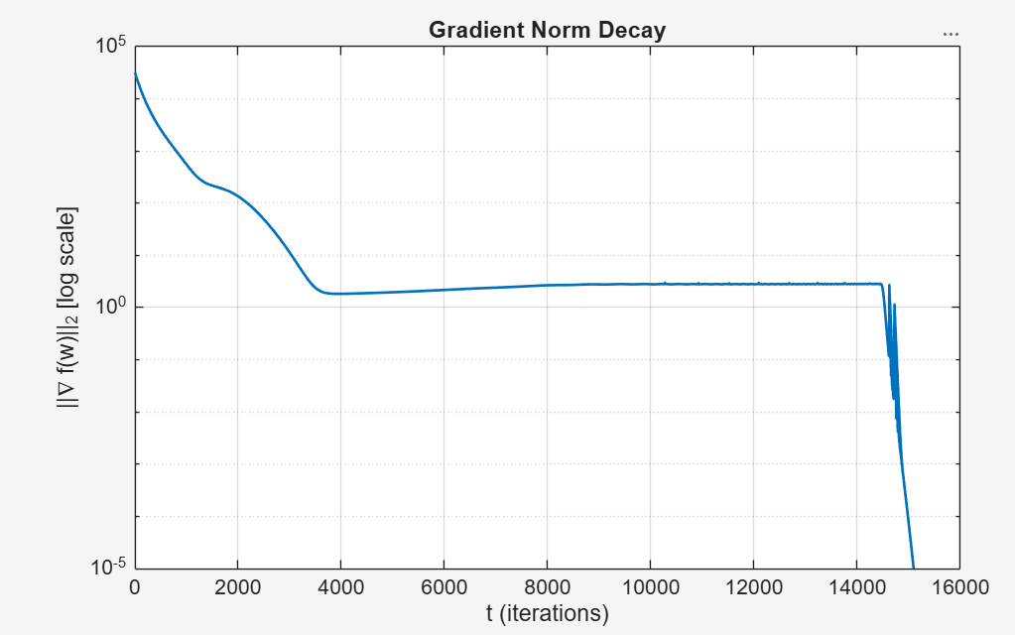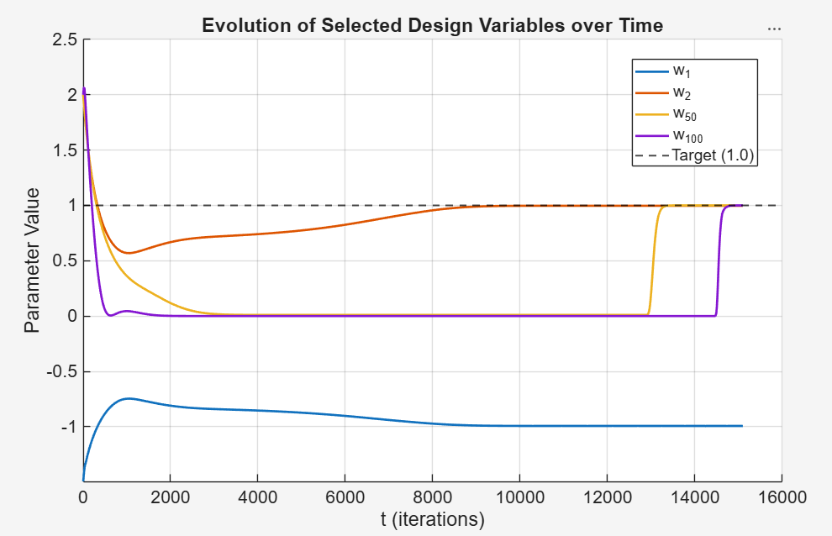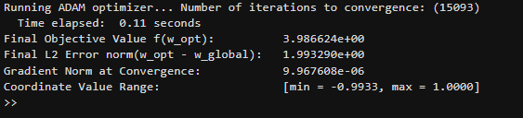

After applying DG:
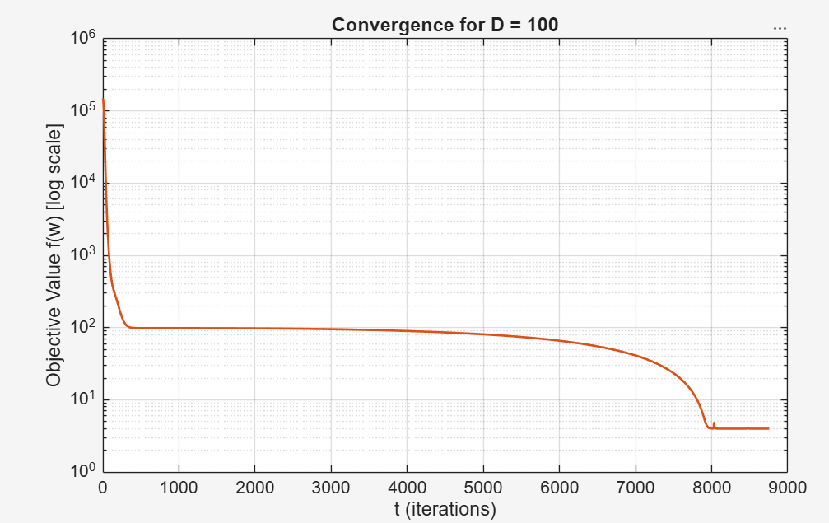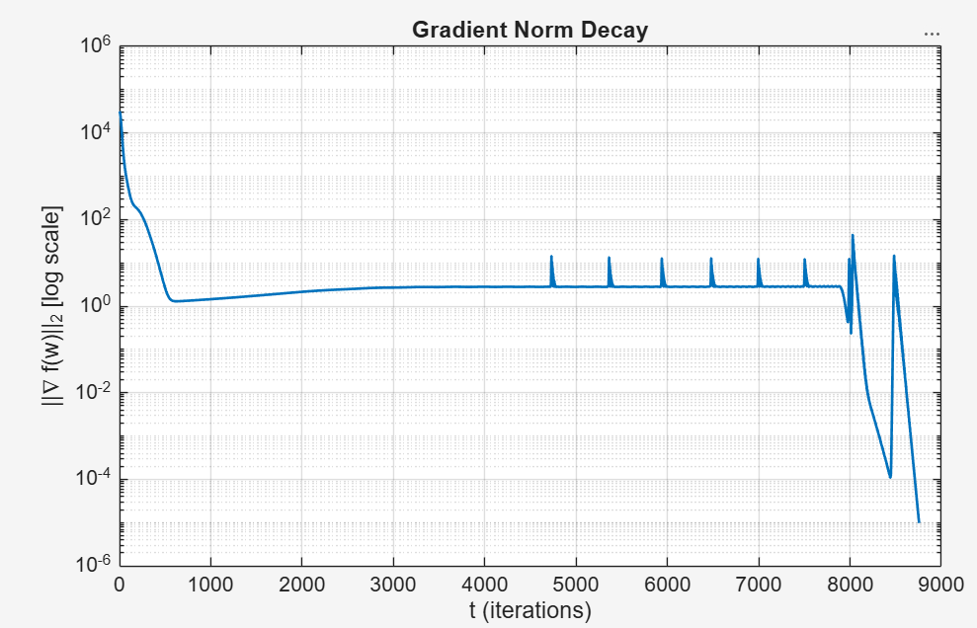
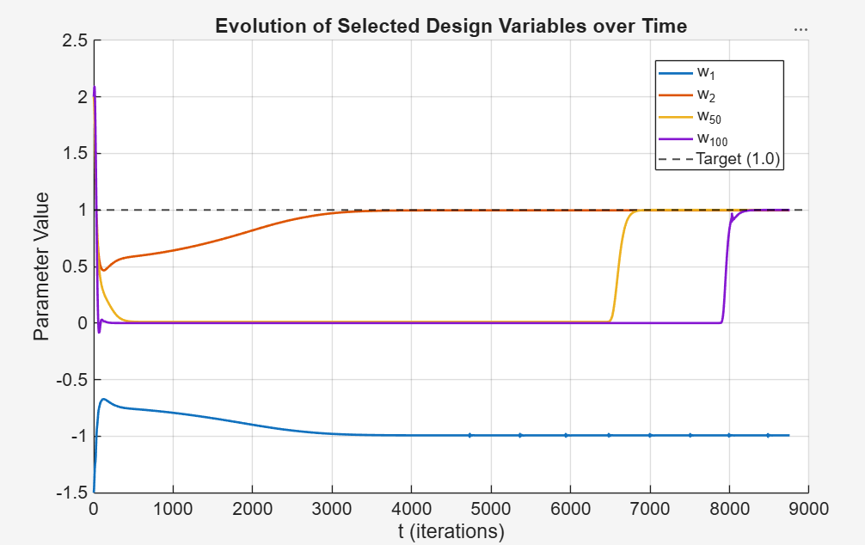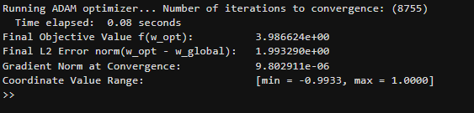

Observation:
There is a reduction in the total iterations needed for convergence and they have almost halved for convergence and the elapsed time for the computation has also decreased.

Black-Box Gradient Estimation (Zeroth-Order Optimization)
Sometimes you have a function you can evaluate (plug in values, get a number) but you cannot differentiate it. No analytical gradient, no adjoint, no automatic differentiation. The function is a "black box" — maybe it's a compiled simulation, a physical experiment, or third-party software.
You still need a gradient to feed Adam. So you estimate it numerically from function evaluations alone.
The methods:
Central Finite Differences (CFD): Perturb each variable both ways, measure the function change.
∂f/∂xᵢ ≈ (f(x + εeᵢ) − f(x − εeᵢ)) / 2ε
Requires 2N function evaluations for N variables. Accurate but expensive.
Simultaneous Perturbation Stochastic Approximation (SPSA): Instead of perturbing one variable at a time, perturb ALL variables simultaneously with a random vector Δ.
ĝ ≈ (f(x + εΔ) − f(x − εΔ)) / 2ε · Δ⁻¹
Requires only 2 function evaluations regardless of N. Much cheaper but noisier. Adam's momentum smooths out this noise naturally — this is exactly the kind of problem Adam was designed for.
Complex-Step Differentiation: A trick where you evaluate f(x + ih) with a tiny imaginary perturbation. The gradient is the imaginary part of the result divided by h. Extremely accurate (no cancellation error) but requires the function to support complex arithmetic.

Perturbing (or a perturbation) means introducing a small, temporary, or controlled disturbance to a system to see how it responds, changes, or recovers

References
Baydin et al., "Online Learning Rate Adaptation with Hypergradient Descent" (2018)

